# Defining Probability

## Overview

* Distinguish between disjoint (mutually exclusive) and independent events.
  + If A and B are independent, then having information on A does not tell us anything about B (and vice versa).
  + If A and B are disjoint, then knowing that A occurs tells us that B cannot occur (and vice versa).
  + Disjoint (mutually exclusive) events are always dependent since if one event occurs we know the other one cannot.

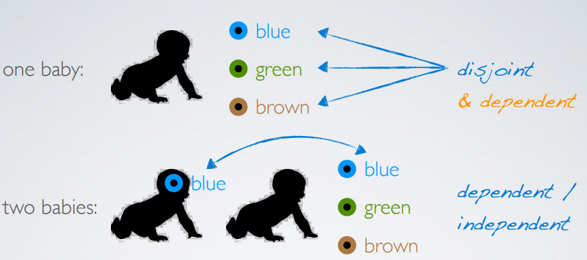

* Define complementary outcomes as mutually exclusive outcomes of the same random process whose probabilities add up to 1.
  + If A and B are complementary, P(A) + P(B) = 1
* Distinguish between union of events (A or B) and intersection of events (A and B).
  + Calculate the probability of union of events using the (general) addition rule:

If A and B are not mutually exclusive, P(A or B) = P(A) + P(B) − P(A and B)

If A and B are mutually exclusive, P (A or B) = P (A) + P (B), since for mutually exclusive events P(A and B) = 0

* + Calculate the probability of intersection of independent events using the multiplication rule:

If A and B are independent, P(A and B) = P(A) × P(B)

If A and B are dependent, P(A and B) = P(A|B) × P(B)

## Random process

In a random process, we know what outcomes could happen, but we don’t know which particular outcome will happen.

## Probability definition

* Frequentist interpretation:

The probability of an outcome is the proportion of times the outcome would occur if we observed the random process an infinite number of times.

* Bayesian interpretation:

A Bayesian interprets probability as a subjective degree of belief. This interpretation allows for prior information to be integrated into the inferential framework.

Largely popularized by revolutionary advance in computational technology and methods during the last twenty years.

## Law of large numbers

Law of large numbers states that as more observations are collected, the proportion of occurrences with a particular outcome converges to the probability of that outcome.

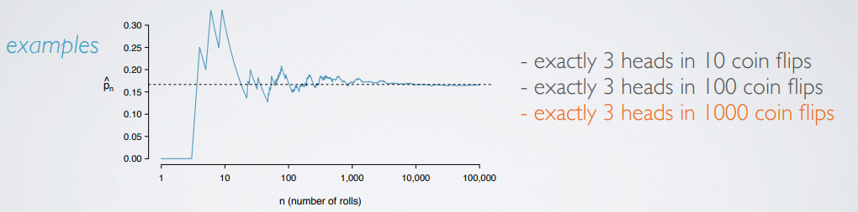

## Sample space

A sample space is a collection of all possible outcomes of a trial.

## Probability distributions

A probability distribution lists all possible outcomes in the sample space, and the probabilities with which they occur.

## Complementary events

Complementary events are two mutually exclusive events whose probabilities add up to 1.

## Disjoint vs. complementary

* Do the sum of probabilities of two disjoint outcomes always add up to 1?

Not necessarily, there may be more than 2 outcomes in the sample space.

* Do the sum of probabilities of two complementary outcomes always add up to 1?

Yes, that’s the definition of complementary.

Complementary events are always disjoint events but not vice versa.

## Independence

Two processes are independent if knowing the outcome of one provides no useful information about the outcome of the other.

For example, outcomes of two tosses of a fair coin are independent.

**Checking for independence:**

P(A|B) = P(A), then A and B are independent.

# Conditional Probability